
Company
Logotype

Cone Beam Computed Tomography- Report



Porur Dental X-rays & CBCT

Patient Name : Miss. Daffodil | Date of Report : 25.03.2024
Age/ Gender : 20 years/ Female | Region of Interest : CBCT Sectional Mandible
Referring doctor: Dr. Godwin | Indication : Implant assessment
Clinical Notes: Nil
PATIENT INFORMATION

CBCT- Sectional Mandible provided
CBCT – IMAGE DETAILS

RADIOGRAPHIC INTERPRETATION

- The tooth 36 is present with hyperdense restorative material within the crown extending upto the apical third of the radicular portion.
- In relation to 38, the long axis of the tooth is perpendicular to that of the adjacent tooth, with the crown of 38 impinging on the distal surface of 37.
- The alveolar bone in relation to the mandibular ridge is present with normal trabecular pattern.

IMPLANT ASSESSMENT

 | 36 region
Sub-Crestal (in mm) | 8.05
Mid- Crestal (in mm) | 10.25
Distance between alveolar ridge and the inferior alveolar nerve canal (in mm) | 15.18
Distance between alveolar ridge and the inferior border of mandible (in mm) | 23.03

RADIOGRAPHIC IMPRESSION

- Root canal treated tooth: 36
- Horizontally impacted tooth: 38

Kindly correlate with clinical findings


IMAGES FOR REFERENCE

RECONSTRUCTED PANORAMIC VIEW

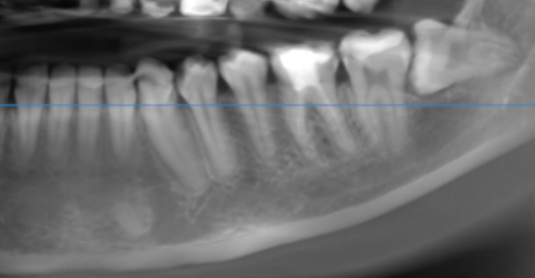

3-DIMENSIONAL VIEW
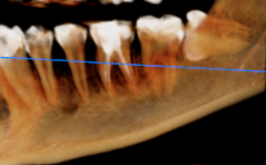

CROSS SECTIONAL VIEW

36 region | 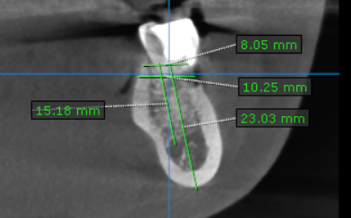

**** End of report ****

